**DESIGN DOCUMENT**

**Submitted By: Bhavin Desai, Swetha Sundararajan**

1. The sequence will generate automated values for logid field of the logs table
2. The package display is used to display the tuples of six different tables used for this project. This package contains the following procedures which take one OUT parameter to return the system ref cursor.

* show_students
* show_classes
* show_enrollments
* show_courses
* show_prerequisites
* show_logs

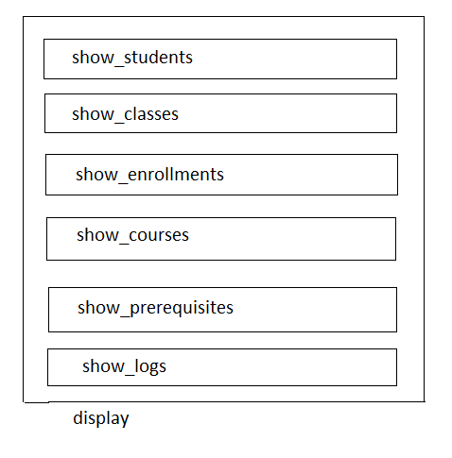

1. The procedure add_stud is used to add student's details to students tables. New student details are added using this procedure. Throw appropriate exceptions.
2. The procedure show_details takes two parameters – sid as IN parameter and ref cursor as OUT parameter that displays the sid, firstname and all courses taken by the student.
3. The procedure show_prereq displays all prerequisite courses for a given course and throw exceptions as mentioned in the requirements document. The third parameter returns the system ref cursor
4. The procedure show_studinclass displays all students who are enrolled in a given class by throwing appropriate exceptions. First parameter is the classid and 2nd parameter is OUT which returns the result through ref cursor
5. The procedure stud_enroll is used to enroll a student in the given course satisfying various conditions as given in the requirements document. Trigger update_class_size is used to update class_size column in classes table as and when a student is enrolled into a class. Throw appropriate exceptions.
6. The procedure drop_class is used to drop a student from a course satisfying various conditons as given in the requirements document. Trigger reduce_class_size is used to update the class_size column in classes table as and when a student drops a course. Throw appropriate exceptions.
7. The procedure del_stud is used to delete a student from the students table. Trigger update_enrollments is used to delete the corresponding students entries from enrollments table. Throw appropriate exceptions.
8. Whenever a student is added or deleted from the students table entries are made to logs table. Triggers tri10_1 and tri10_2 are used for this purpose respectively.

Whenever a student is successfully enrolled or dropped from a course, entries are made to logs table. Triggers tri10_3 and tri10_4 are used for this purpose.

